CUONG ASSIGNED MID-TERM TASKS
My tasks:
- 1.2. Review at least three models, algorithms, or approaches related to the project topic.
- 1.4. Compare the advantages, disadvantages, and applicability of the reviewed models/approaches to the project.
- 2.3. Present the data preparation process, including segmentation, normalization, noise reduction, labeling, and dataset splitting.
- 3.1. Present the architecture or workflow of the proposed solution.

1.2. Review of Related Models and Approaches
- MFCC + CNN:

Audio → Preprocessing → MFCC → CNN → Global Average Pooling → Command

MFCC provides a compact feature representation and serves as an MFCC-based baseline. This is a lightweight and fast approach, but it may lose some detailed time-frequency information.

- Log-Mel + CNN:

Audio → Log-Mel Spectrogram → CNN → Fully Connected Layer → Command

CNN learns local acoustic patterns directly from the Log-Mel spectrogram. It provides a good balance between accuracy, model size, and inference speed for short speech commands.

- CRNN (CNN-GRU):

Audio → Log-Mel Spectrogram → CNN → Reshape to time sequence → 2-Layer GRU → Temporal Mean Pooling → LayerNorm + Dropout + Linear → Command

CNN extracts local spectral features, the GRU models temporal dependencies across the speech frames. CRNN is more suitable for longer or more complex speech sequences, but it requires more computation and training time.

We applied CNN-GRU-based CRNN approach, because it achieves the best and most balanced performance with a test accuracy of 97.46% and a macro-F1 score of 97.14%, outperforming the MFCC-CNN and Log-Mel CNN baselines.

Approach | Results
MFCC + CNN | 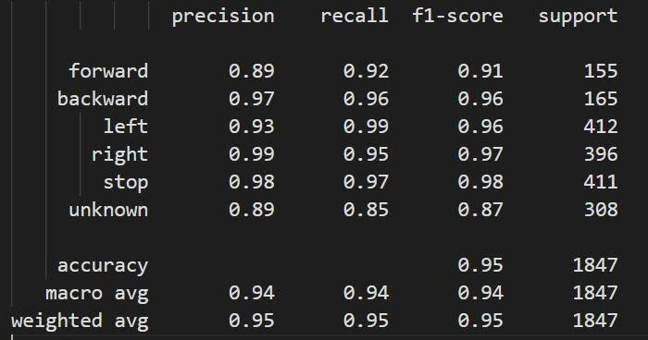
Log-Mel + CNN | 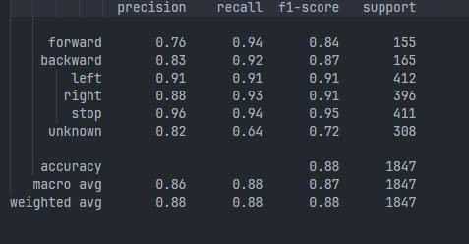
Log-Mel + CRNN (CNN-GRU) | 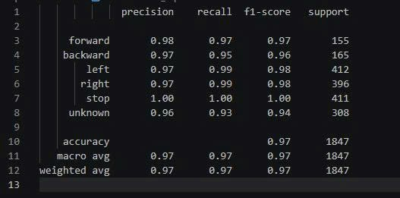

1.4. Comparison and Applicability to the Project
Criterion | MFCC + CNN | Log-Mel + CNN | Log-Mel + CNN-GRU CRNN
Feature requirements | Handcrafted MFCC features; compact representation. | Log-Mel spectrogram with clear time-frequency structure. | Log-Mel features followed by convolution and recurrent layers.
Model size | Small, ~ 23.8K parameters | Small, ~ 23.8K parameters | Larger, 370,038 parameters
Training cost | Low and fast to train. | Moderate and practical for the current dataset. | Higher because recurrent layers increase computation.
Inference latency | Low; suitable for limited hardware. | Low; efficient on a CPU for short clips. | Higher than the CNN baselines, but still suitable for real-time CPU inference at ~ 4.84 ms/sample
Advantages | Lightweight, fast to train, and suitable for limited resources. MFCC features are compact and easy to compute. | Simple and practical baseline. Log-Mel preserves clearer time-frequency patterns and works efficiently for short speech commands. | Combines strong local feature extraction with temporal modeling. Better captures sequential information across speech frames.
Disadvantages | MFCC retains less detailed time-frequency information and may limit performance compared with Log-Mel-based models | Temporal dependencies are modeled only indirectly through convolution and pooling | Larger model size, higher training cost, and higher inference cost than the CNN baselines.

2.3. Data Preparation Process
- Dataset used: Google Speech Commands.
- Target classes: forward, backward, left, right, stop, and unknown.
- Process pipeline:
Google Speech Commands
→ Official train/validation/test Subsets
→ Target and Unknown Label Selection
→ Load WAV
→ Mono Conversion
→ Resampling to 16 kHz
→ Padding/Trimming to 1 Second
→ Peak Amplitude Normalization
→ Log-Mel Extraction
→ Model Input
Non-target words are sampled and assigned to the unknown class.
Each audio file is converted to mono, resampled to 16 kHz, and adjusted to 16,000 samples. Short recordings are zero-padded, while long recordings are trimmed.
Main feature is a Log-Mel spectrogram using a 25 ms window, a 10 ms hop, a 400-point FFT, and 64 Mel bands.
We used the official Google Speech Commands training, validation, and test subsets to ensure a fixed and reproducible evaluation. The official subsets also help prevent recordings from the same speaker from appearing in both training and testing.

3.1. Proposed System Architecture and Workflow
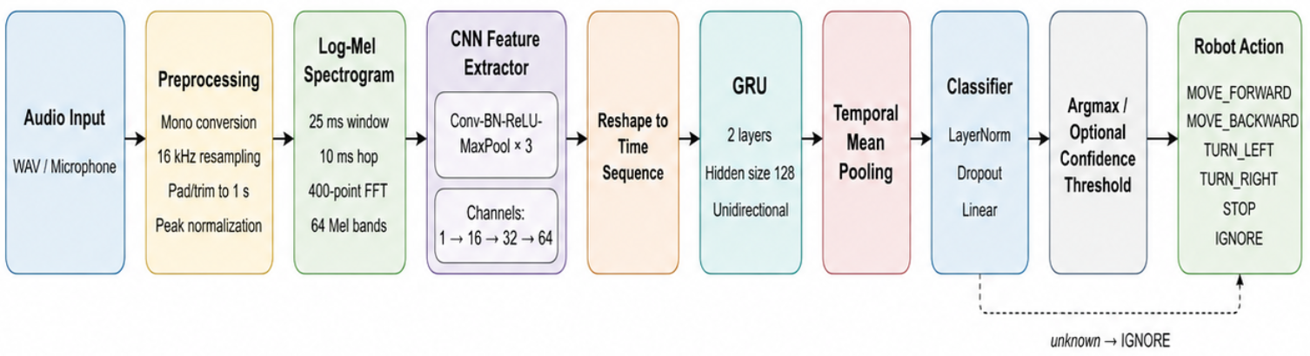

The proposed CRNN combines CNN for local time-frequency feature extraction and GRU for temporal sequence modeling. During model development, preprocessed audio from the training and validation sets is converted into Log-Mel spectrograms.
The model outputs logits, which are converted into probabilities using softmax, and argmax selects the predicted class.
The unknown class is mapped to IGNORE, while valid commands are mapped to the corresponding robot actions (MOVE_FORWARD, MOVE_BACKWARD, TURN_LEFT, TURN_RIGHT, STOP, or IGNORE)

